Major project documentation

“AIRLINES RESERVATION SYSTEM”

***is submitted to***

***Department of Computer Applications,***



**Submitted To:**

**Submitted By:**

**Name of Student**: Amit Sharma & sahil talwar

**Roll No:**  RA3802A24 & RA3802A21

**REG. NO. :**  10807276 & 10805845

**Project Undertaken:**

**AIRLINES RESERVATION SYSTEM**

**Acknowledgement**

The satisfaction that accompanies that the successful completion of any task would be incomplete without the mention of people whose ceaseless cooperation made it possible, whose constant guidance and encouragement crown all efforts with success. We are grateful to our project guide “Mr. Shakti kundu” for the guidance, inspiration and constructive suggestions that helpful us in the preparation of this project.

We are also thankful to my colleagues with whom we have fruitful discussions which have helped us a lot in giving a final shape to the program.

**AMIT SHARMA**

|  |  |  |  |  |
| --- | --- | --- | --- | --- |
| INDEX | | | | |
| Sr. No. | Table OF Content | | | Page No |
| 1.) | Project name and description | | | 4 |
| 2.) | Profile OF The Problem | | | 5 |
| 3.) | Existing System | | | 6-7 |
|  | **a.)** | **Introduction** | |  |
| **b.)** | **Existing Software** | |
| **c.)** | **What’s new in the system to be developed?** | |
| 4.) | Problem Analysis | | | 8-10 |
|  | a.) | Product Definition | |  |
| b.) | Feasibility Analysis | |
| c.) | Project Plan | |
| 5.) | Software Requirement Analysis | | | 10-11 |
|  | a.) | Introduction | |  |
| b.) | Specific Requirement | |
| 6.) | Design | | | 11-20 |
|  | a.) | System Design | |  |
| b.) | Detailed Design | |
| **7.)** | **Testing** | | | **20** |
|  | **a.)** | | **Functional Testing** |  |
| **b.)** | | **Structural Testing** |
| **c.)** | | **Levels of testing** |
| **d.)** | | **Testing of the Project** |
| **8.)** | **implementation** | | | **24** |
|  | **a.)** | | **Implementation of the project** |  |
| **9.)** | **User Manual** | | | **27** |
|  | **a.)** | | **The complete guide for the project developed** |  |
| **10.)** | **Source code** | | | **27** |
| **11.)** | **bibliography** | | | **40** |

1. **Project Name and Description**

**AIRLINES RESERVATION SYSTEM**



The Airline Reservations System (ARS) was one of the earliest changes to improve efficiency. ARS eventually evolved into the [Computer Reservations System](http://en.wikipedia.org/wiki/Computer_Reservations_System) (CRS). A Computer Reservation System is used for the reservations of a particular airline and interfaces with a [Global Distribution System](http://en.wikipedia.org/wiki/Global_Distribution_System) (GDS) which supports travel agencies and other distribution channels in making reservations for most major airlines in a single system.

Airline Reservations Systems contain airline schedules, fare tariffs, passenger reservations and ticket records. An airline's direct distribution works within their own reservation system, as well as pushing out information to the GDS. A second type of direct distribution channel are consumers who use the internet or mobile applications to make their own reservations.

**INVENTORY MANAGEMENT**

An airline’s inventory contains all flights with their available seats. The inventory of an airline is generally divided into service classes (e.g. First, Business or Economy class) and up to 26 booking classes, for which different prices and booking conditions apply. Inventory data is imported and maintained through a Schedule Distribution System over standardized interfaces. One of the core functions of the inventory management is the inventory control. Inventory control steers how many seats are available in the different booking classes, by opening and closing individual booking classes for sale. In combination with the fares and booking conditions stored in the Fare Quote System the price for each sold seat is determined.

**DISPLAY AND RESERVATION**

Users access an airline’s inventory through an availability display. It contains all offered flights for a particular city-pair with their available seats in the different booking classes. This display contains flights which are operated by the airline itself as well as code share flights which are operated in co-operation with another airline. If the city pair is not one on which the airline offers service it may display a connection using its' own flights or display the flights of other airlines.

The availability of seats of other airlines is updated through standard industry interfaces. Depending on the type of co-operation it supports access to the last seat (Last Seat Availability) in real-time. Reservations for individual passengers or groups are stored in a so-called Passenger Name Record ([PNR](http://en.wikipedia.org/wiki/PNR)). Among other data, the [PNR](http://en.wikipedia.org/wiki/PNR) contains personal information such as name, contact information or special services requests (SSRs) .

e.g. for a vegetarian meal, as well as the flights (segments) and issued tickets. Some reservation systems also allow to store customer data in profiles to avoid data re-entry each time a new reservation is made for a known passenger.

**Fare Quote and Ticketing**

The Fares data store contains fare tariffs, rule sets, routing maps, class of service tables, and some tax information that construct the price - "the fare". Rules like booking conditions (e.g. minimum stay, advance purchase, etc.) are tailored differently between different city pairs or zones, and assigned a class of service corresponding to its appropriate inventory bucket. Inventory control can also be manipulated manually through the availability feeds, dynamically controlling how many seats are offered for a particular price by opening and closing particular classes.

1. **Profile of the problem**

The web based “airline reservation system” project is an attempt to stimulate the basic concepts of airline reservation system. The system enables the customer to do the things such as search for airline flights for two travel cities on a specified date, choose a flight based on the details, reservation of flight and cancellation of reservation.  
  
The system allows the airline passenger to search for flights that are available between the two travel cities, namely the “Departure city” and “Arrival city” for a particular departure and arrival dates. The system displays all the flight’s details such as flight no, name, price and duration of journey etc.  
After search the system display list of available flights and allows customer to choose a particular flight. Then the system checks for the availability of seats on the flight. If the seats are available then the system allows the passenger to book a seat. Otherwise it asks the user to choose another flight.  
To book a flight the system asks the customer to enter his details such as name, address, city, state, credit card number and contact number. Then it checks the validity of card and book the flight and update the airline database and user database.

**Disadvantages in existing system:->**

* Time consuming
* Possibly of loosing data
* Lack of security
* Difficulties in maintaining records
* Human error will be frequent
* searching the records manuallyleads time consuming

1. **Existing System**

* **Introduction**

In the existing system all the data are stored manually to an excel sheet and filed accordingly in a filing cabinet.

**SPECIFIC OBJECTIVES:-**

1. Maintaining safe records
2. Should be easier to find for a record in the database
3. The loss of data in any corruption of any files in the system will be avoided due to any natural case
4. Minimizing errors of the information recorded in the system while entering to the system
5. The new system should be user friendly
6. Data entry should be fast
7. There should be a method of keeping the information from unauthorized users.

**Methods of data collection and input Structure of Airline :**

|  |
| --- |
|  |
|  |
|  |
|  |
|  |
|  |
|  |
|  |
|  |
|  |

**Name:**

**Address:**

**Phnumber:**

**Dob:**

**Nic:**

**Passport No:**

**Nationality:**

**Destination:**

**Airline:**

**Day of Dep:**

**Time:**

When the customer ask to book a flight at first the booking form is been filled with his/her full:->

Name, Address, National ID, Email, Address, Contact Number, Destination, Booking date and the Retuned date as shown above the form. After that the document is been signed by the office staff.

# 

* **Exiting software**

**METHODOLOGIES**

**HARDWARE:**  
PROCESSOR : PENTUIUM IV 2.6 GHz  
RAM : 512MB DD RAM  
MONITOR : 15” COLOR  
HARD DISK :250 GB  
CDDRIVE : LG52X  
KEYBOARD : STANDARD 102 KEYS  
MOUSE :OPTICAL MOUSE  
  
  
**SOFTWARE:**  
FORNT END :JAVA,HTML,SERVLETS  
BACKEND : ORACLE 10i  
OPERATING SYSTEM : WINDOWS XP

* **DFD for Present system**

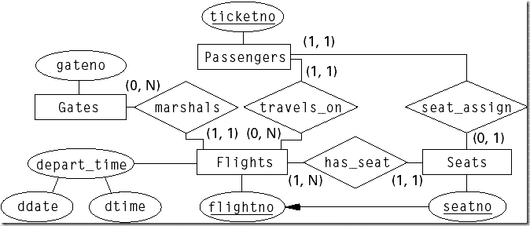

* **What’s new in the system to be developed?**

**APPLICABILITY**

* This project solve the problem of the traditional reservation system.
* With certain changes it can be applicable on any online reservation field.
* One of the most benefits in today’s life is that reservation can be made from any place of the world.
* The user need not to be present the physically to draw a reservation slip. It will automatically do by the system

**ADVANTAGES**

1. It easy to learn and adjust to the system

2. this system does not require the staff to be highly educated

3. the requirements to tackle this job may be limited to

4. Willing to work long hours

5. data is not easily lost

6. it easy to manage the system due to the high number of staff working

1. **Problem Analysis**

* **Product definition**

1 .**Plane type**: This defines the physical type of the plane. It dictates the capacity of first,

executive, business and economy seats that a flight can have.

2. **Airport**: An airport consists of a name, the city it is in, and its airport id.

3. **Flight** : A flight is identified by its flightid. A flight denotes an unique “plane”, i.e. one which is scheduled to run at a certain time, from one place to another. A flight runs over a set of routes.

4. **Route**: A route is simply a tuple of airports: (StartAirport,EndAirport), and every route has a unique route id. A flight runs over a route only if it runs from the startairport to the endairport, possibly halting in between at other airports. A route is elementary for a flight if the flight runs nonstop from the start airport to the end airport.

5. **Ticket** : A ticket is uniquely identified by a ticketid. The ticket may be a passenger ticket or a cargo ticket, and can be booked under a passenger profile or a user profile. A ticket is booked on a flight for a route that the flight is associated with. A passenger ticket contains details about the passenger, and a cargo ticketabout a cargo. The

6. **Scheme** : A scheme consists of discount percentages on various classes awarded on certain flights, and for certain people or round trips. Scheme ids have a type code defining what they they are valid for, and a period code showing whether they are valid as of now or no. A scheme is defined for a flight and for a particular route.

7.**Official**: An official is a person who can book tickets for others, and can find retrieve the complete list of passengers boarding a flight. An official works at an airport.

8.**Profile**: A profile denotes that a person has been verified to be genuine and can book tickets/ execute certain queries.

* **Feasibility Analysis**

1. **FlightRouteScheme**: This is a ternary relation that says that a flight runs over a route using a particular scheme. The scheme can be null, but not the flight id and route id. The attributes in this include:

a. Fare for the flight between the two stops given by the route specified.

b. Any scheme valid on this flight, for this route

c. Number of booked seats on this flight, route.

d. A flag value indicating whether this is an elementary or complex route for this flight.

2. **FlightRouteTicket**: This ternary relation says that a ticket is booked on a certain flight over one route that the flight allows. It has only the primary keys of each entity.

3. **ProfileTicket relation**: This consists of two relations: user profile related to ticket and the official profile related to ticket. This is done to keep the user and official profiles separate and independent from each other.

* **Project Plan**

**The plan of this project is to make a software which is:->>**

* Interpreted and high performance
* Distributed
* Dynamic
* Secure

**Services Reservation in Airlines Abstract:-**

This Abstract report on a study about examining airlines' reservation services.

An apparatus, method, and program for determining a price of an option to purchase an airline ticket, and for facilitating the sale & exercise of those options.

Pricing of the options may be based on departure location criteria, destination location criteria, and travel criteria. The attributes selected for examination included….

(1) requirements of reservation services.

(2) provision of extra benefits.

(3) factors affecting reservation time.

(4) provision ofadditional services/facilities.

Empirical results indicatedthat some airlines did not provide all components in the chosenattributes and that airlines in these regions differedsignificantly in certain dimensions of the chosen attributes.

1. **Software requirement Analysis**

* **Introduction**

Requirements analysis is critical to the success of a development project. [Requirements](http://en.wikipedia.org/wiki/Requirement) must be documented, actionable, measurable, testable, related to identified business needs or opportunities, and defined to a level of detail sufficient for system design. Requirements can be [architectural](http://en.wikipedia.org/wiki/System_architecture), [structural](http://en.wikipedia.org/wiki/Structure), [behavioral](http://en.wikipedia.org/wiki/Behavior), [functional](http://en.wikipedia.org/wiki/Functional_requirements), and [non-functional](http://en.wikipedia.org/wiki/Non-functional_requirements).

* **General Description**

**Visual Basic .NET** (**VB.NET**) is an [object-oriented](http://en.wikipedia.org/wiki/Object-oriented_programming) [computer programming language](http://en.wikipedia.org/wiki/Programming_language) that can be viewed as an evolution of the classic [Visual Basic](http://en.wikipedia.org/wiki/Visual_Basic) (VB) which is implemented on the [.NET Framework](http://en.wikipedia.org/wiki/.NET_Framework). Microsoft currently supplies two major implementations of Visual Basic: [Microsoft Visual Studio](http://en.wikipedia.org/wiki/Microsoft_Visual_Studio), which is [commercial software](http://en.wikipedia.org/wiki/Commercial_software) and [Microsoft Visual Studio Express](http://en.wikipedia.org/wiki/Microsoft_Visual_Studio_Express), which is [free of charge](http://en.wikipedia.org/wiki/Freeware).

* **Specific Requirements**
* **System**
  + Windows XP Service Pack 2 or above (for 2010 release, Service Pack 3)
  + Windows Server 2003 Service Pack 1 or above
  + Windows Server 2003 R2 or above
  + Windows Vista
  + Windows Server 2008
  + Windows 7
  + Linux with Mono (only works with .NET 2.0 applications)
* **Hardware**
  + Minimum: 1.6 GHz CPU, 384 MB RAM, 1024×768 display, 5400 RPM hard disk
  + Recommended: 2.2 GHz or higher CPU, 1024 MB or more RAM, 1280×1024 display, 7200 RPM or higher hard disk

1. **Design**

* **System Design**

**Systems design** is the process of defining the architecture, components, modules, interfaces, and [data](http://en.wikipedia.org/wiki/Data) for a [system](http://en.wikipedia.org/wiki/System) to satisfy specified [requirements](http://en.wikipedia.org/wiki/Requirement). One could see it as the application of [systems theory](http://en.wikipedia.org/wiki/Systems_theory) to [product development](http://en.wikipedia.org/wiki/Product_development).

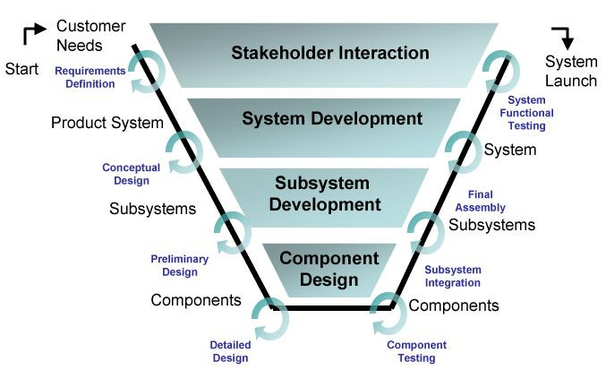

There is some overlap with the disciplines of [systems analysis](http://en.wikipedia.org/wiki/Systems_analysis), [systems architecture](http://en.wikipedia.org/wiki/Systems_architecture) and [systems engineering](http://en.wikipedia.org/wiki/Systems_engineering). If the broader topic of [product development](http://en.wikipedia.org/wiki/Product_development) "blends the perspective of marketing, design, and manufacturing into a single approach to product development, then design is the act of taking the marketing information and creating the design of the product to be manufactured. Systems design is therefore the process of defining and developing [systems](http://en.wikipedia.org/wiki/System) to satisfy specified [requirements](http://en.wikipedia.org/wiki/Requirement) of the user

* **Detailed design**

**Screen shots:**

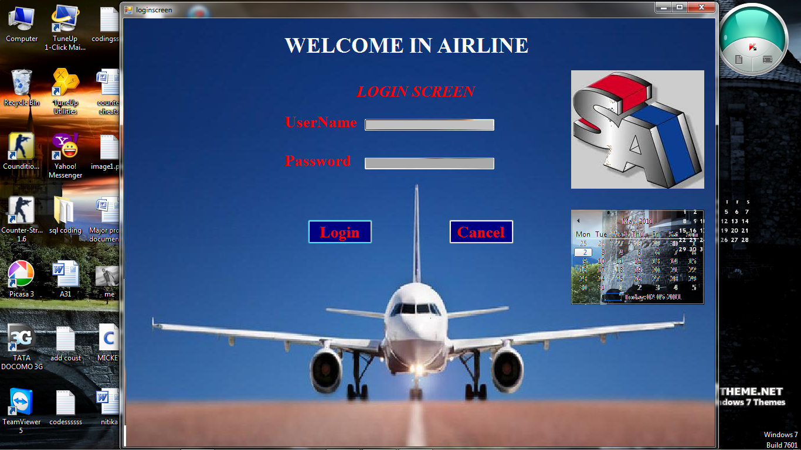

**LOGIN Screen:-**

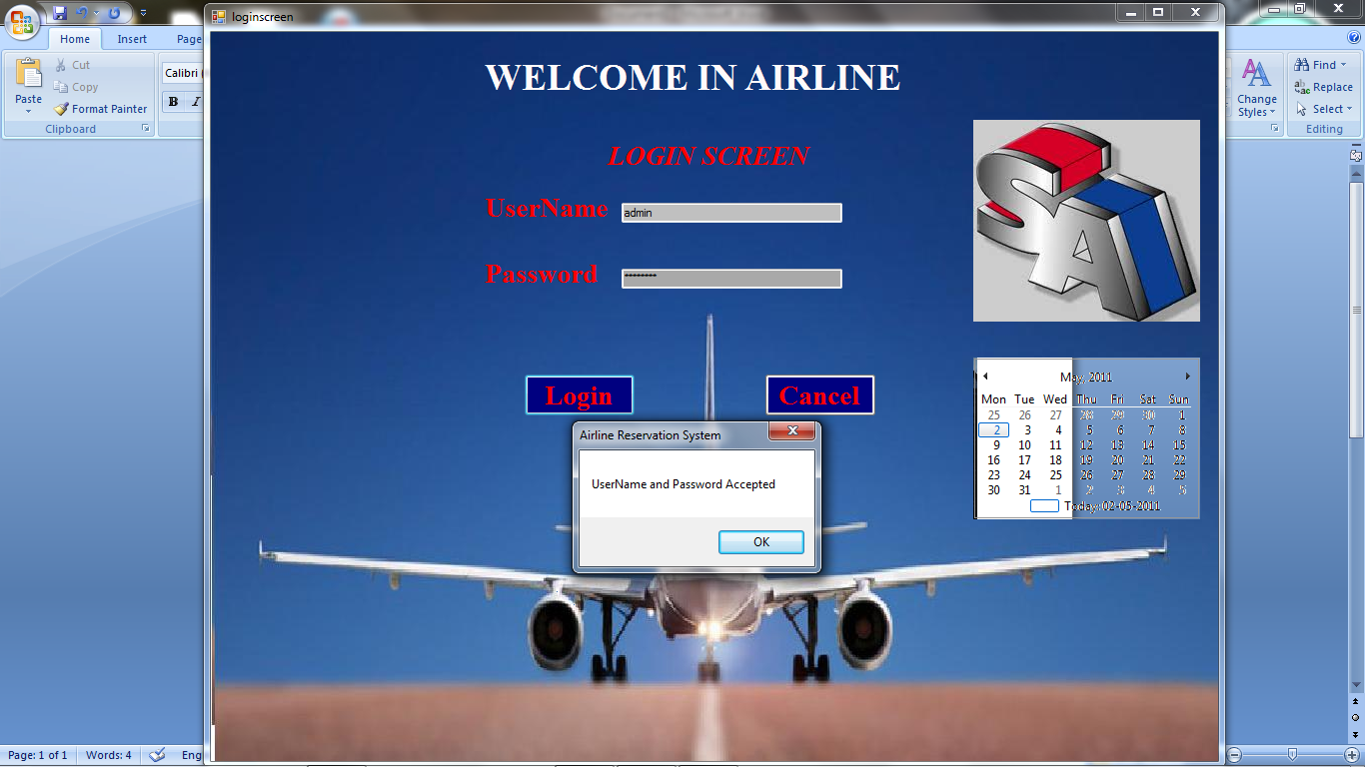

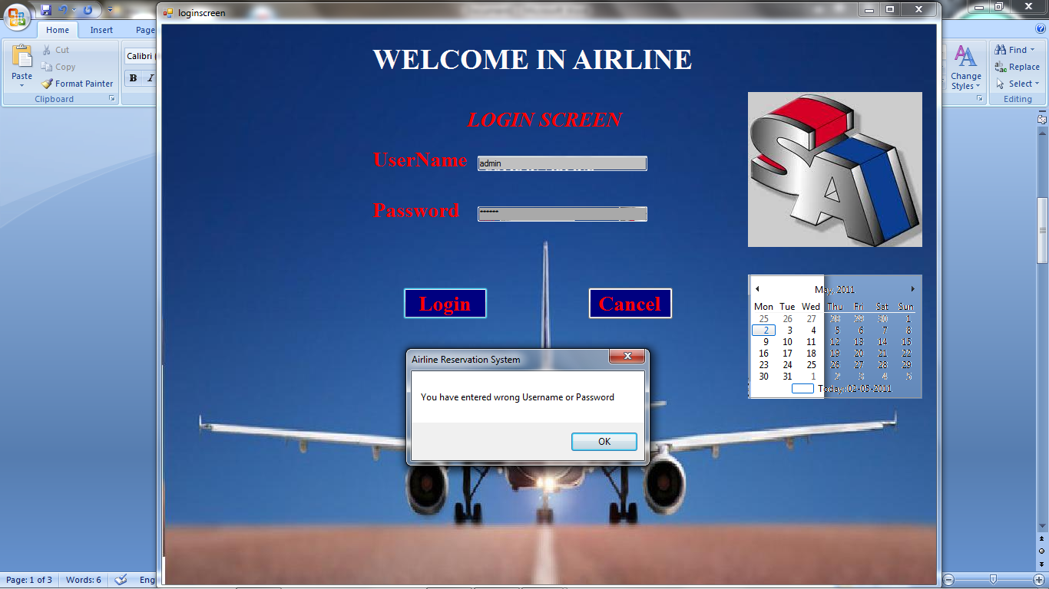

**Main menu:-**

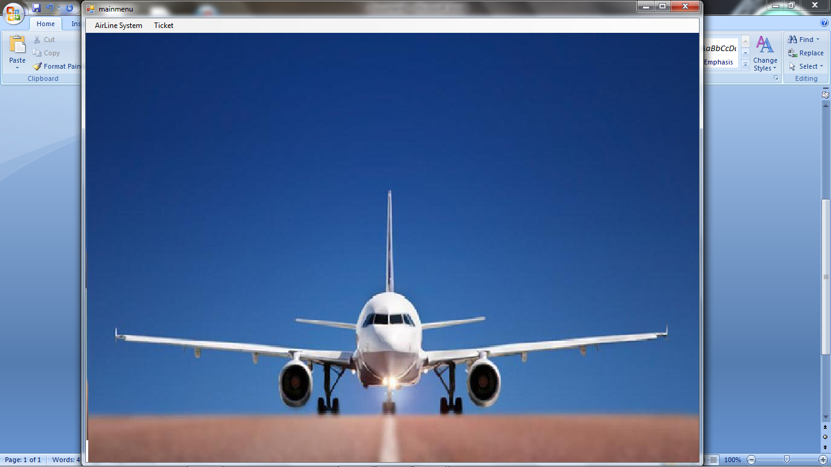

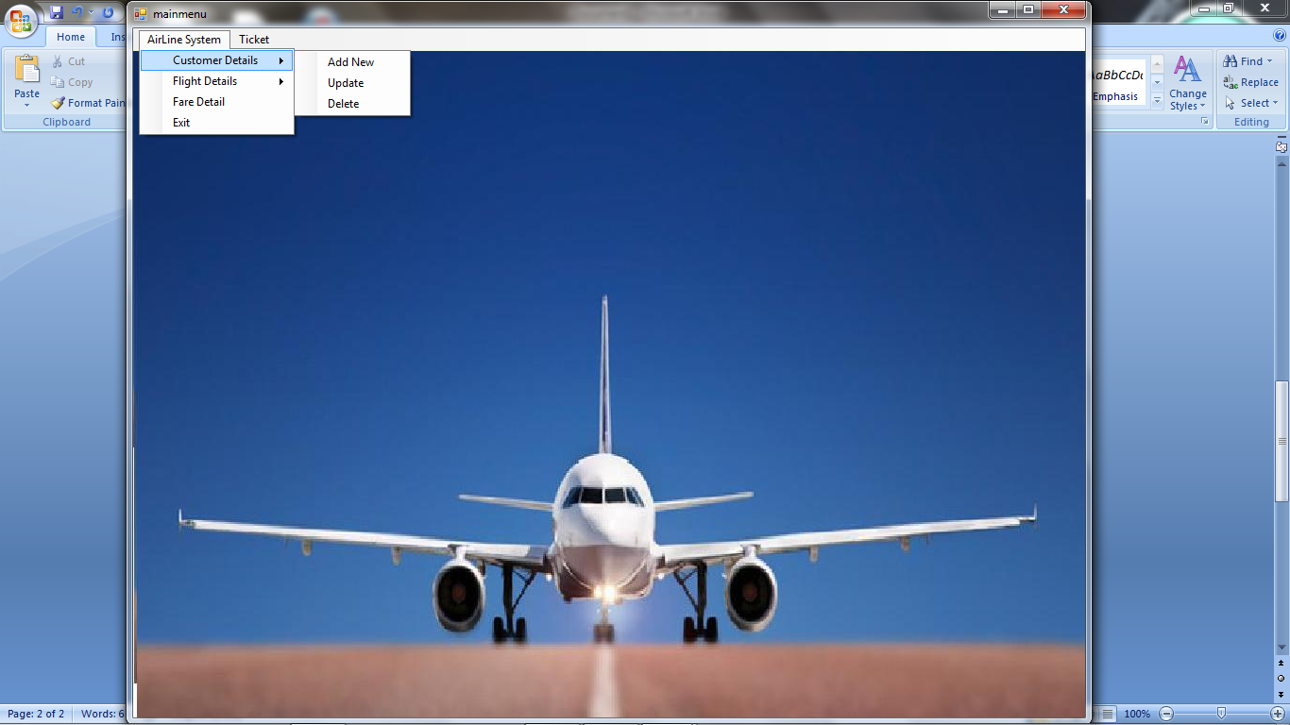

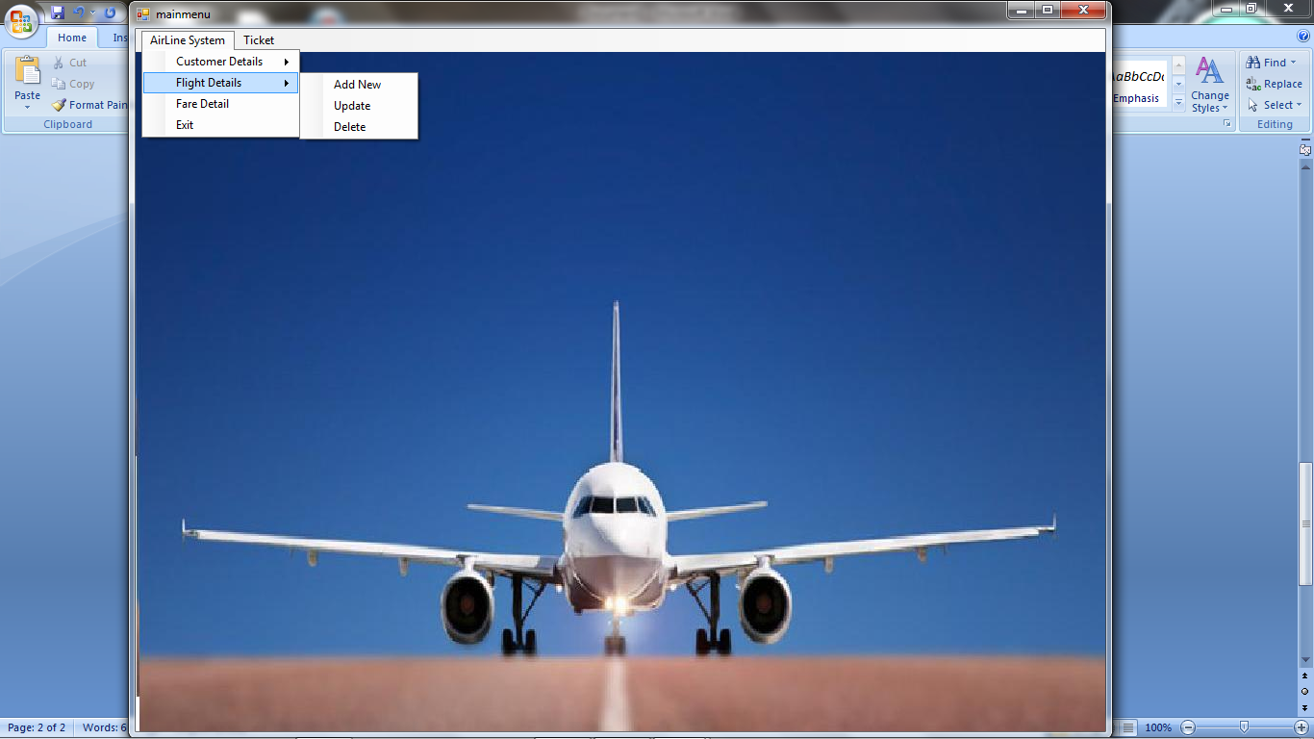

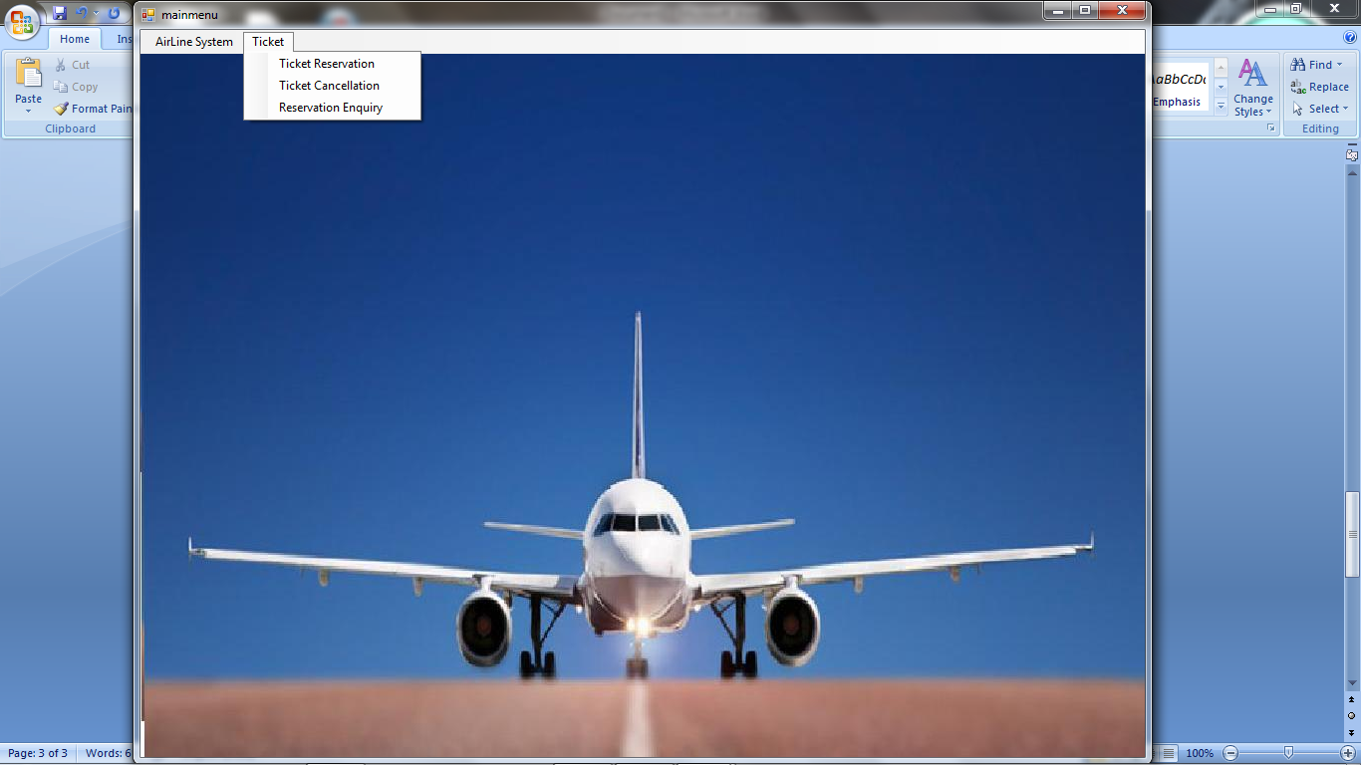

**Customer add**

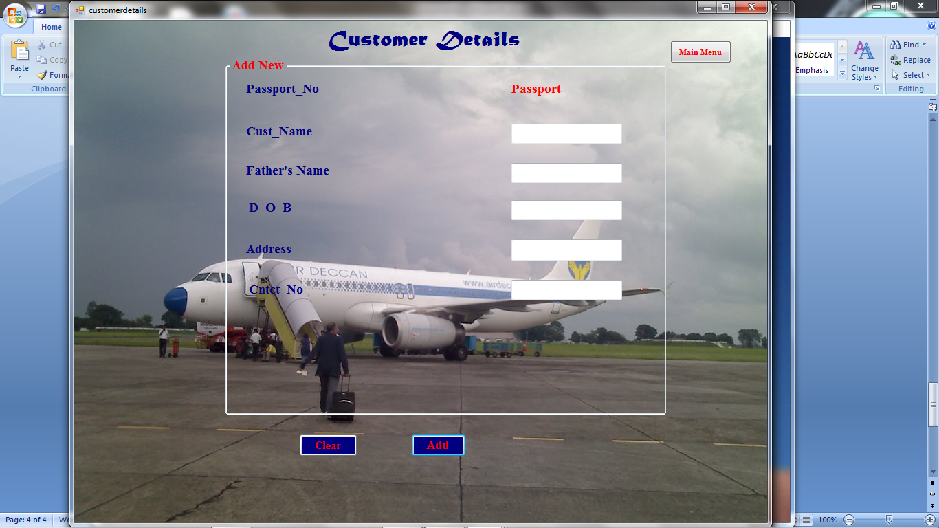

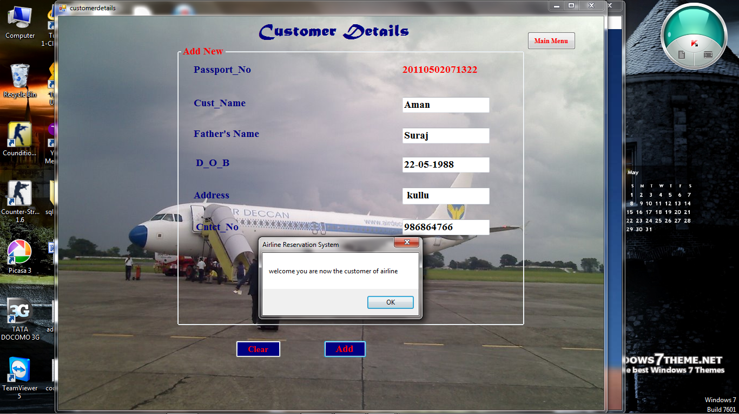

**Update**

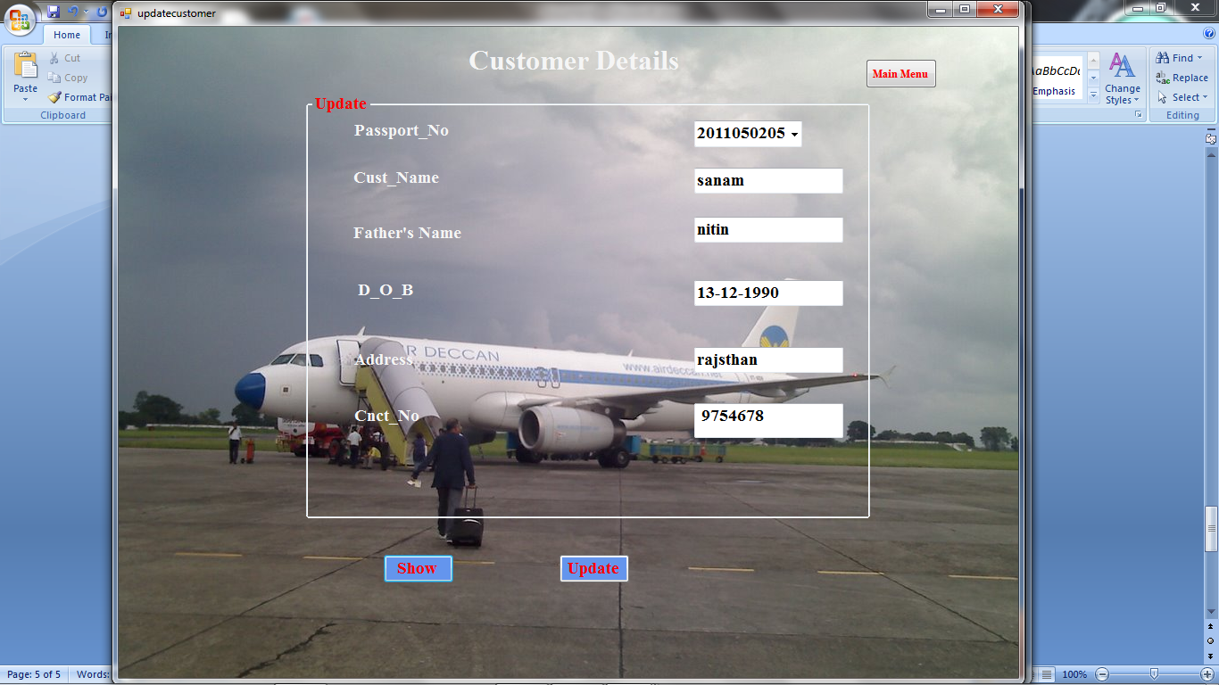

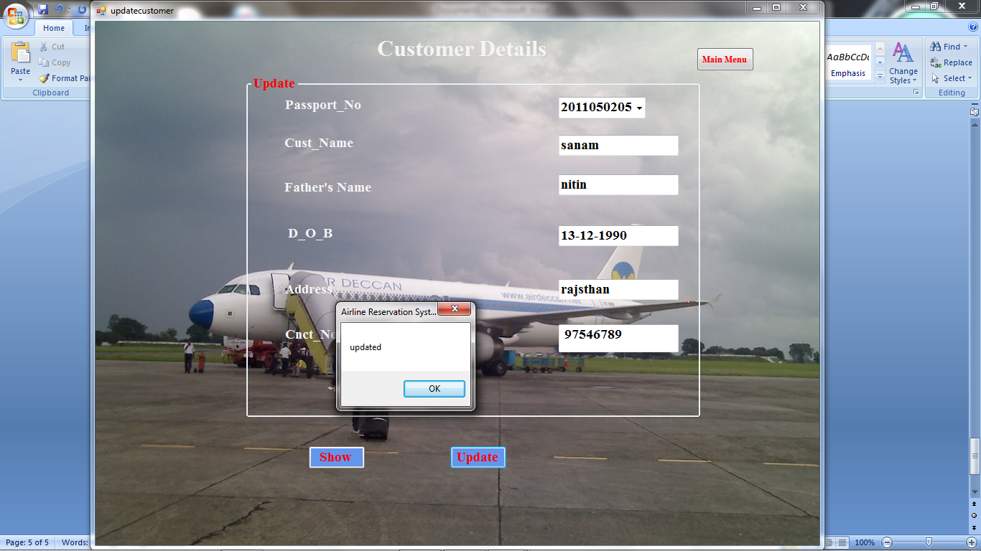

**NEW ADD FLIGHT**

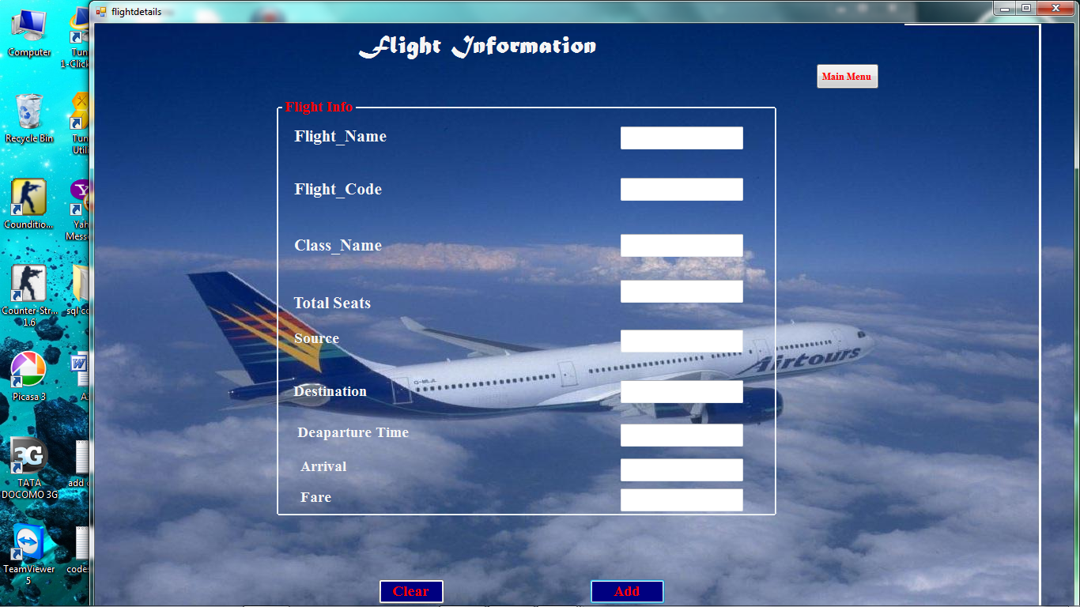

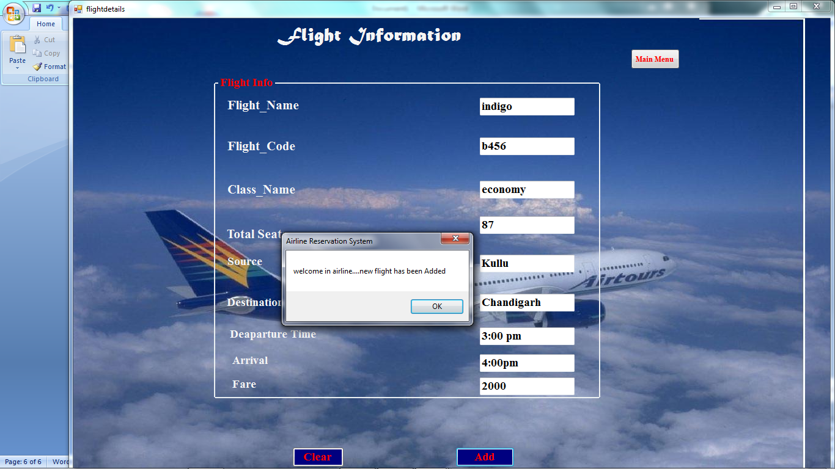

**UPDATE FLIGHT**

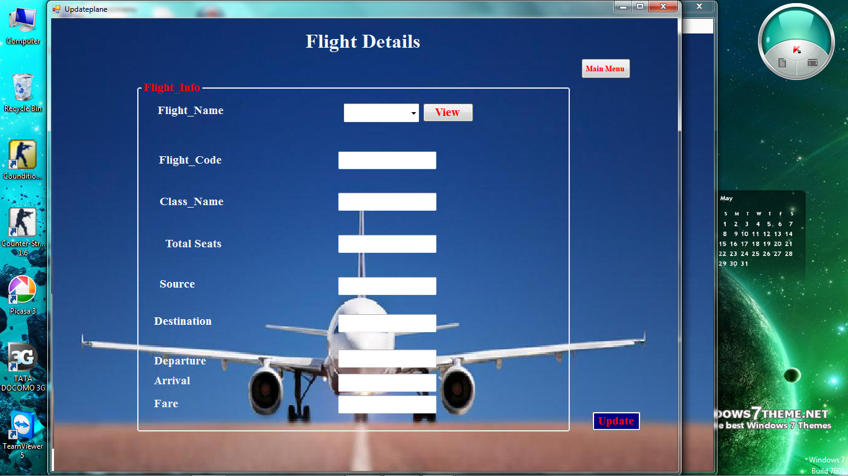

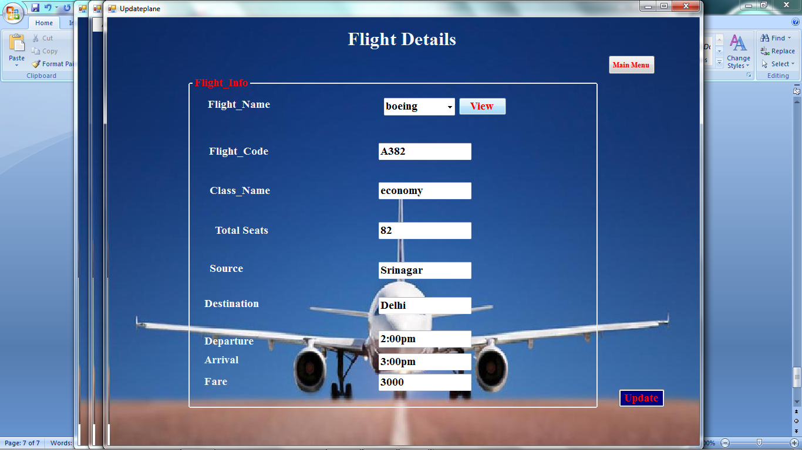

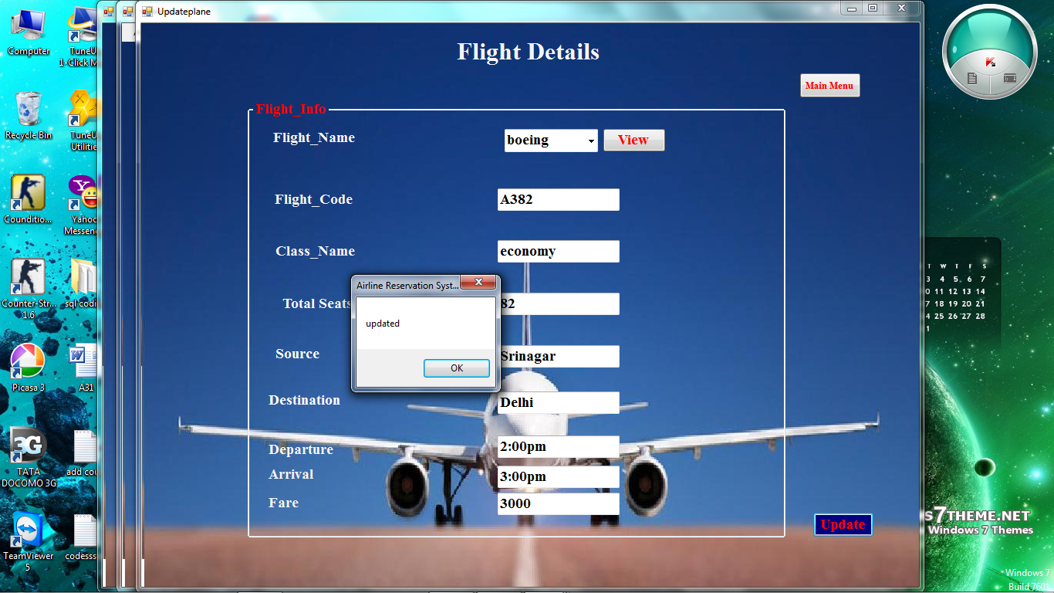

**FARE**

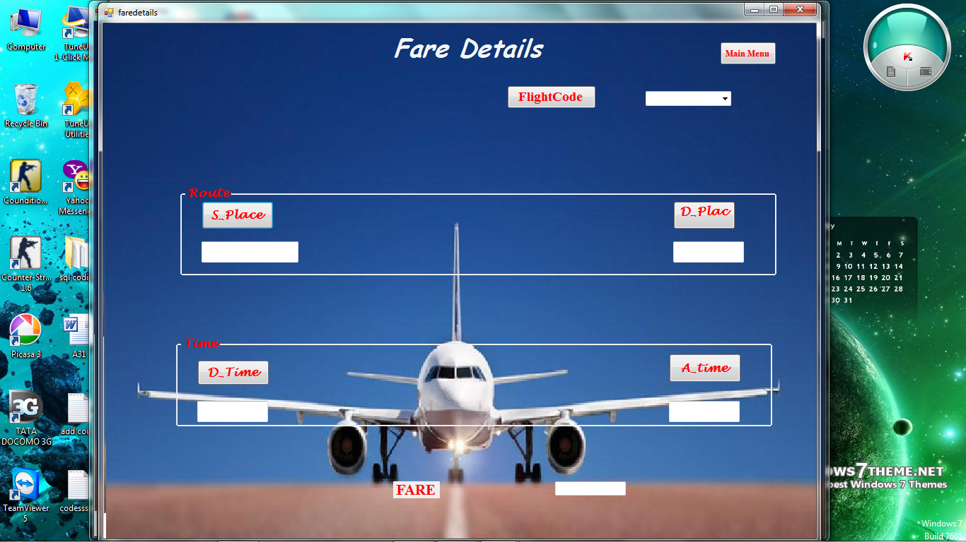

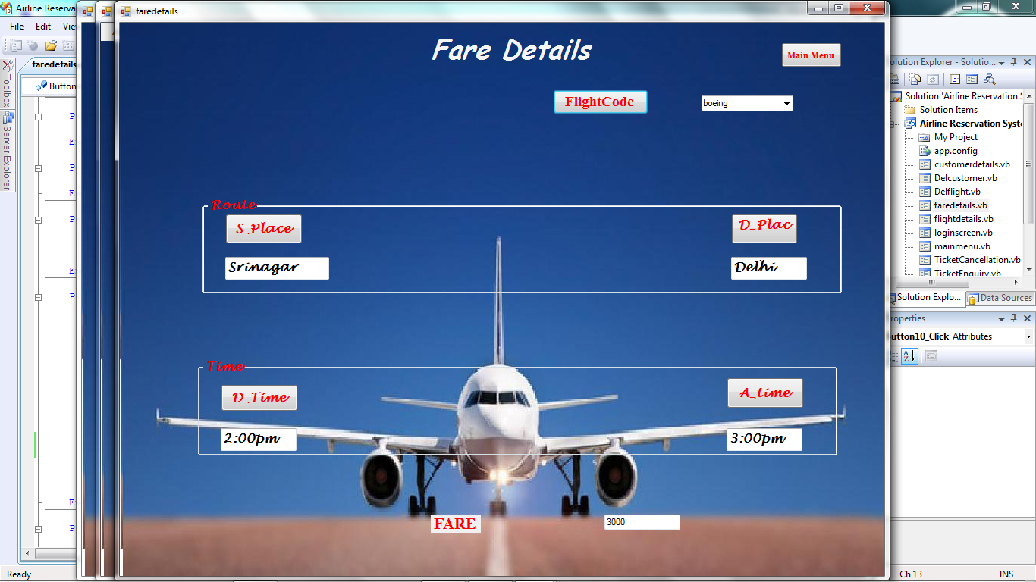

**TICKET RESERVATION**

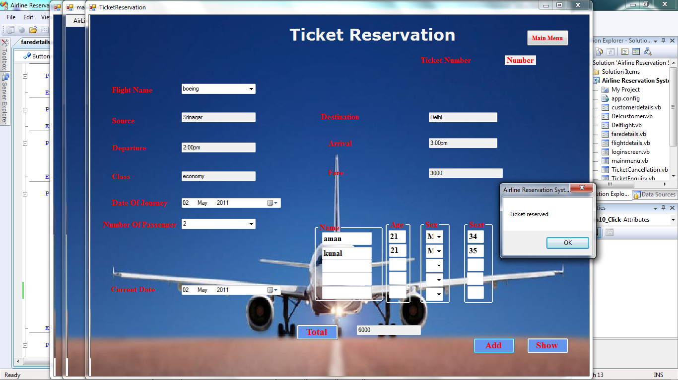

**TICKET CANCEL**

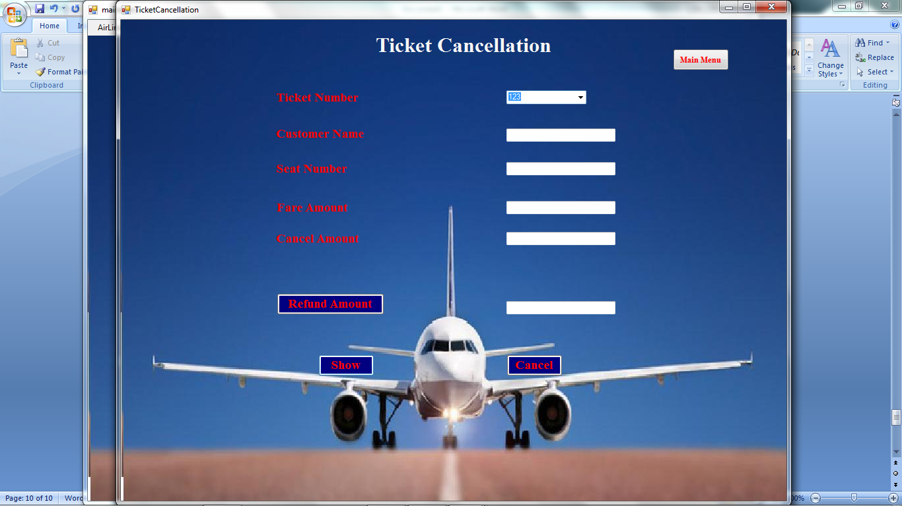

1. **Testing**

* **Functional Testing**

Functional testing is a type of [black box testing](http://en.wikipedia.org/wiki/Black_box_testing) that bases its test cases on the specifications of the software component under test. Functions are tested by feeding them input and examining the output, and internal program structure is rarely considered (Not like in [white-box testing](http://en.wikipedia.org/wiki/White-box_testing)).

Functional testing differs from [system testing](http://en.wikipedia.org/wiki/System_testing) in that functional testing a program by checking it against ... design document or specification", while system testing "validate a program by checking it against the published user or system requirements.

**Functional testing typically involves five steps:->**

1. The identification of functions that the software is expected to perform
2. The creation of input data based on the function's specifications
3. The determination of output based on the function's specifications
4. The execution of the test case
5. The comparison of actual and expected outputs

**System testing** of software or hardware is testing conducted on a complete, integrated system to evaluate the system's compliance with its specified [requirements](http://en.wikipedia.org/wiki/Requirements). System testing falls within the scope of [black box testing](http://en.wikipedia.org/wiki/Black_box_testing), and as such, should require no knowledge of the inner design of the code or logic.

* **Structural Testing**

It determines the durability and integrity of complete structures or sub-assemblies, usually in multi-axis testing systems that replicate end use conditions.  The product range extends from single-axis component testing through to complex testing systems for the simulation of almost all service loads affecting a vehicle or component. IST offers a wide range of modular standard testing systems for use in the automotive industry to test car components such as suspensions and steering systems.  Alternatively, systems can be engineered to meet specific customer requirements.

* **Levels of testing**

**1) Unit testing**

**2) Integration testing**

**3) System testing**

**4) User acceptance testing**

**1)unit testing:** individual software components of appication are tested in isolation from other part of the program.

**bigban testing:** individual software components of an aplivation are combined at once into system .every module is first init tested.then the entire sysetm is tested for communication interfaces between them.

**bottom-up testing:** in bottom-up integration testing begins from bottom of the module hierarchy and work up to the top to simulate higher level modules .every module is first unit tested then modules are added in acsending hierarchial order.lower level modules are tested first then the next set of higher level modules are tested with previuosly tested lower level modules.

**top-down testing:**  begins testing from top of the module hierarchy and

work down to the bottom to simulate lower interfacing modules.every module is first unit tested then the modules are added in descending hierarchial order.higher level modules are tested first then the next set of lower level modules are tested with previously tested higher level modules.

* **Testing of the Project**

**Proofreading**

Proofreading (also proof-reading) traditionally means reading a proof copy of a text in order to detect and correct any errors. Modern proofreading often requires reading copy at earlier stages as well.

**Double Entry**

In the double entry system transactions are entered twice in the accounts. For example, the same car purchased will result an increase in the "vehicle" account and a decrease in "cash" account. Therefore, the difference between the two is that in single entry system, transaction is entered only once and in double entry system it is entered twice

This is to find if any errors are present in the system. To check for the errors an artificial made database are fed to system and been checked and the errors will be verified accordingly. **Two main ways of data verifications are:-**

**Single Method:** this is also known as proof reading method-

Typing the data twice and comparing the two database at the same time. This method is also known as double entry method.

1. **Implementation**

* **Implementation of the project**











Update





1. **Project Legacy**

* **Current status of project**
* **Data has been added**
* **New customer login**
* **Deletion in the data**
* **Updating**
* **Generate id automatically**
* **Remaining area of concern**

1. **User Manual: The complete guide (help file) for the project developed**

* **Book which prefer: VB.NET 2008**

### Pro VB 2008 and the .NET 3.5 Platform

**Author: Andrew Troelsen  
 Publisher: APress**

1. **Source code**

**CODING IN LOGIN SCREEN:-**

Public Class Form1

Private Sub Button1_Click(ByVal sender As System.Object, ByVal e As System.EventArgs) Handles Button1.Click

If TextBox1.Text = "admin" And TextBox2.Text = "password" Then

MsgBox("UserName and Password Accepted")

mainmenu.Show()

Else

MsgBox("You have entered wrong Username or Password")

End If

End Sub

Private Sub Button3_Click(ByVal sender As System.Object, ByVal e As System.EventArgs)

TextBox1.Clear()

TextBox2.Clear()

End Sub

Private Sub Button2_Click(ByVal sender As System.Object, ByVal e As System.EventArgs) Handles Button2.Click

MsgBox("Thanks for using Airline Reservation System ")

Me.Close()

End Sub

End Class

**CODING IN MAIN MENU**

Public Class mainmenu

Private Sub ExitToolStripMenuItem_Click(ByVal sender As System.Object, ByVal e As System.EventArgs) Handles ExitToolStripMenuItem.Click

Me.Close()

End Sub

Private Sub FareDetailToolStripMenuItem_Click(ByVal sender As System.Object, ByVal e As System.EventArgs) Handles FareDetailToolStripMenuItem.Click

faredetails.Show()

End Sub

Private Sub TicketReservationToolStripMenuItem_Click(ByVal sender As System.Object, ByVal e As System.EventArgs) Handles TicketReservationToolStripMenuItem.Click

Ticketreservation.Show()

End Sub

Private Sub AddNewToolStripMenuItem_Click(ByVal sender As System.Object, ByVal e As System.EventArgs) Handles AddNewToolStripMenuItem.Click

customerdetails.Show()

End Sub

Private Sub DeleteToolStripMenuItem_Click(ByVal sender As System.Object, ByVal e As System.EventArgs) Handles DeleteToolStripMenuItem.Click

Delcustomer.Show()

End Sub

Private Sub UpdateToolStripMenuItem_Click(ByVal sender As System.Object, ByVal e As System.EventArgs) Handles UpdateToolStripMenuItem.Click

updatecustomer.Show()

End Sub

Private Sub AddNewToolStripMenuItem1_Click(ByVal sender As System.Object, ByVal e As System.EventArgs) Handles AddNewToolStripMenuItem1.Click

flightdetails.Show()

End Sub

Private Sub DeleteToolStripMenuItem1_Click(ByVal sender As System.Object, ByVal e As System.EventArgs) Handles DeleteToolStripMenuItem1.Click

Delflight.Show()

End Sub

Private Sub UpdateToolStripMenuItem1_Click(ByVal sender As System.Object, ByVal e As System.EventArgs) Handles UpdateToolStripMenuItem1.Click

Updateplane.Show()

End Sub

Private Sub TicketCancellationToolStripMenuItem_Click(ByVal sender As System.Object, ByVal e As System.EventArgs) Handles TicketCancellationToolStripMenuItem.Click

TicketCancellation.Show()

End Sub

Private Sub ReservationEnquiryToolStripMenuItem_Click(ByVal sender As System.Object, ByVal e As System.EventArgs) Handles ReservationEnquiryToolStripMenuItem.Click

TicketEnquiry.Show()

End Sub

Private Sub Button1_Click(ByVal sender As System.Object, ByVal e As System.EventArgs)

Me.Close()

End Sub

Private Sub CustomersToolStripMenuItem_Click(ByVal sender As System.Object, ByVal e As System.EventArgs)

customerdetails.Show()

End Sub

Private Sub FlightsToolStripMenuItem_Click(ByVal sender As System.Object, ByVal e As System.EventArgs)

flightdetails.Show()

End Sub

End Class

**CODING IN ADD NEW CUSTOMER:-**

Imports System.Data

Imports System

Imports System.Collections

Imports System.Console

Imports System.Linq

Imports System.Web

Imports System.Data.SqlClient

Public Class customerdetails

Private Sub Button5_Click(ByVal sender As System.Object, ByVal e As System.EventArgs) Handles Button5.Click

If TextBox1.Text = "" Or TextBox2.Text = "" Or TextBox7.Text = "" Or TextBox4.Text = "" Then

MsgBox("fill the information properly")

ElseIf IsNumeric(TextBox1.Text) Then

MsgBox("name should not be numeric")

ElseIf IsInputChar(TextBox4.Text) Then

MsgBox("contct should not be char")

ElseIf IsNumeric(TextBox2.Text) Then

MsgBox(" Father's name should not be numeric")

ElseIf IsInputChar(TextBox6.Text) Then

MsgBox("Insert D_O_B")

ElseIf IsNumeric(TextBox7.Text) Then

MsgBox("address should not be numeric")

Me.Hide()

End If

Dim con As New SqlConnection("server=SAHIL-PC;database=D:\Airline Reservation System - Copy\Airline Reservation System\data\dbARS.mdf;Integrated Security=True")

con.Open()

Dim PassportNo As String

PassportNo = Format(DateTime.Now, "yyyyMMddhhmmss")

Label4.Text = PassportNo

Dim cmd As New SqlCommand("insert into customer_dtls values(@passportno,@custname,@fathername,@d_o_b,@address,@contactno)", con)

cmd.CommandType = CommandType.Text

cmd.Parameters.Add("@passportNo", SqlDbType.VarChar, 50).Value = PassportNo

cmd.Parameters.Add("@custname", SqlDbType.VarChar, 50).Value = TextBox1.Text

cmd.Parameters.Add("@fathername", SqlDbType.VarChar, 50).Value = TextBox2.Text

cmd.Parameters.Add("@d_o_b", SqlDbType.DateTime).Value = TextBox6.Text

cmd.Parameters.Add("@address", SqlDbType.VarChar, 50).Value = TextBox7.Text

cmd.Parameters.Add("@contactno", SqlDbType.VarChar, 50).Value = TextBox4.Text

cmd.ExecuteNonQuery()

cmd.Dispose()

con.Close()

MsgBox("welcome you are now the customer of airline")

End Sub

Private Sub Button1_Click_1(ByVal sender As System.Object, ByVal e As System.EventArgs) Handles Button1.Click

mainmenu.Show()

Me.Hide()

End Sub

Private Sub Button2_Click(ByVal sender As System.Object, ByVal e As System.EventArgs) Handles Button2.Click

TextBox1.Clear()

TextBox2.Clear()

TextBox4.Clear()

TextBox6.Clear()

TextBox7.Clear()

End Sub

Private Sub TextBox6_TextChanged(ByVal sender As System.Object, ByVal e As System.EventArgs) Handles TextBox6.TextChanged

If TextBox6.Text = "" Then

MsgBox("Insert D_O_B")

End If

End Sub

Private Sub TextBox7_TextChanged(ByVal sender As System.Object, ByVal e As System.EventArgs) Handles TextBox7.TextChanged

If TextBox7.Text = "" Then

MsgBox("Insert Address")

End If

End Sub

Private Sub TextBox4_TextChanged(ByVal sender As System.Object, ByVal e As System.EventArgs) Handles TextBox4.TextChanged

If TextBox4.Text = "" Then

MsgBox("Insert Contact_No")

End If

End Sub

Private Sub TextBox2_TextChanged(ByVal sender As System.Object, ByVal e As System.EventArgs) Handles TextBox2.TextChanged

If TextBox2.Text = "" Then

MsgBox("Insert Father's Name")

End If

End Sub

Private Sub TextBox1_TextChanged(ByVal sender As System.Object, ByVal e As System.EventArgs) Handles TextBox1.TextChanged

If TextBox1.Text = "" Then

MsgBox("Insert Your Name")

End If

End Sub

End Class

**CODING IN UPDATE CUSTOMER:-**

Imports System.Data

Imports System

Imports System.Collections

Imports System.Console

Imports System.Linq

Imports System.Web

Imports System.Data.SqlClient

Public Class updatecustomer

Private Sub Button1_Click(ByVal sender As System.Object, ByVal e As System.EventArgs)

Me.Close()

End Sub

Private Sub Button2_Click(ByVal sender As System.Object, ByVal e As System.EventArgs) Handles Button2.Click

Dim con As New SqlConnection("server=SAHIL-PC;database=D:\Airline Reservation System - Copy\Airline Reservation System\data\dbARS.mdf;Integrated Security=True")

con.Open()

Dim adp As SqlDataReader

Dim cmd As New SqlCommand("select * from customer_dtls where passportNo=" + "'" + ComboBox1.Text + "'", con)

adp = cmd.ExecuteReader()

While adp.Read

TextBox2.Text = adp(1)

TextBox3.Text = adp(2)

TextBox4.Text = adp(3)

TextBox5.Text = adp(4)

TextBox6.Text = adp(5)

End While

adp.Close()

con.Close()

End Sub

Private Sub Button3_Click(ByVal sender As System.Object, ByVal e As System.EventArgs) Handles Button3.Click

Dim con As New SqlConnection("server=SAHIL-PC;database=D:\Airline Reservation System - Copy\Airline Reservation System\data\dbARS.mdf;Integrated Security=True")

con.Open()

Dim cmd As New SqlCommand("Update customer_dtls set CustName=" + "'" + TextBox2.Text + "'" + "," + "Fathername=" + "'" + TextBox3.Text + "'" + "," + "D_O_B=" + "'" + TextBox4.Text + "'" + "," + "Address=" + "'" + TextBox5.Text + "'" + "," + "ContactNo=" + "'" + TextBox6.Text + "'" + "where PassportNo=" + "'" + ComboBox1.Text + "'", con)

cmd.CommandType = CommandType.Text

cmd.ExecuteNonQuery()

cmd.Dispose()

con.Close()

MsgBox("updated")

End Sub

Private Sub updatecustomer_Load(ByVal sender As System.Object, ByVal e As System.EventArgs) Handles MyBase.Load

Dim con As New SqlConnection("server=SAHIL-PC;database=D:\Airline Reservation System - Copy\Airline Reservation System\data\dbARS.mdf;Integrated Security=True")

con.Open()

Dim adp As SqlDataReader

Dim cmd As New SqlCommand("select * from customer_dtls", con)

adp = cmd.ExecuteReader()

While adp.Read

ComboBox1.Items.Add(adp(0))

End While

adp.Close()

End Sub

Private Sub Button1_Click_1(ByVal sender As System.Object, ByVal e As System.EventArgs) Handles Button1.Click

mainmenu.Show()

Me.Close()

End Sub

End Class

**CODING IN FLIGHT DETAILS:-**

Imports System.Data

Imports System

Imports System.Collections

Imports System.Console

Imports System.Linq

Imports System.Web

Imports System.Data.SqlClient

Public Class flightdetails

Private Sub Button2_Click(ByVal sender As System.Object, ByVal e As System.EventArgs) Handles Button2.Click

Dim con As New SqlConnection("server=SAHIL-PC;database=D:\Airline Reservation System - Copy\Airline Reservation System\data\dbARS.mdf;Integrated Security=True")

con.Open()

Dim cmd As New SqlCommand("insert into Flight_dtls values(@flightname,@flightcode,@classname,@totalseats,@flightsource,@flightdestination,@departure,@arrival,@fare)", con)

cmd.CommandType = CommandType.Text

cmd.Parameters.Add("@flightname", SqlDbType.VarChar, 50).Value = TextBox1.Text

cmd.Parameters.Add("@flightcode", SqlDbType.VarChar, 50).Value = TextBox2.Text

cmd.Parameters.Add("@classname", SqlDbType.VarChar, 50).Value = TextBox3.Text

cmd.Parameters.Add("@totalseats", SqlDbType.VarChar, 50).Value = TextBox4.Text

cmd.Parameters.Add("@flightsource", SqlDbType.VarChar, 50).Value = TextBox5.Text

cmd.Parameters.Add("@flightdestination", SqlDbType.VarChar, 50).Value = TextBox6.Text

cmd.Parameters.Add("@departure", SqlDbType.VarChar, 50).Value = TextBox7.Text

cmd.Parameters.Add("@arrival", SqlDbType.VarChar, 50).Value = TextBox8.Text

cmd.Parameters.Add("@fare", SqlDbType.VarChar, 50).Value = TextBox9.Text

cmd.ExecuteNonQuery()

cmd.Dispose()

con.Close()

MsgBox("welcome in airline....new flight has been Added")

End Sub

Private Sub Button3_Click(ByVal sender As System.Object, ByVal e As System.EventArgs) Handles Button3.Click

TextBox1.Clear()

TextBox2.Clear()

TextBox3.Clear()

TextBox4.Clear()

TextBox5.Clear()

TextBox6.Clear()

End Sub

Private Sub Button1_Click_1(ByVal sender As System.Object, ByVal e As System.EventArgs) Handles Button1.Click

mainmenu.Show()

Me.Hide()

End Sub

End Class

**CODING IN UPDATE Plane**

Imports System.Data

Imports System

Imports System.Collections

Imports System.Console

Imports System.Linq

Imports System.Web

Imports System.Data.SqlClient

Public Class Updateplane

Private Sub Button1_Click(ByVal sender As System.Object, ByVal e As System.EventArgs)

Me.Close()

End Sub

Private Sub Button2_Click(ByVal sender As System.Object, ByVal e As System.EventArgs) Handles Button2.Click

Dim con As New SqlConnection("server=SAHIL-PC;database=D:\Airline Reservation System - Copy\Airline Reservation System\data\dbARS.mdf;Integrated Security=True")

con.Open()

Dim cmd As New SqlCommand("Update flight_dtls set flightcode=" + "'" + TextBox2.Text + "'" + "," + "classname=" + "'" + TextBox3.Text + "'" + "," + "totalseats=" + "'" + TextBox4.Text + "'" + "," + "flightsource=" + "'" + TextBox5.Text + "'" + "," + "flightdestination=" + "'" + TextBox6.Text + "'" + "where flightname=" + "'" + ComboBox1.Text + "'", con)

cmd.CommandType = CommandType.Text

cmd.ExecuteNonQuery()

cmd.Dispose()

con.Close()

MsgBox("updated")

End Sub

Private Sub Updateplane_Load(ByVal sender As System.Object, ByVal e As System.EventArgs) Handles MyBase.Load

Dim con As New SqlConnection("server=SAHIL-PC;database=D:\Airline Reservation System - Copy\Airline Reservation System\data\dbARS.mdf;Integrated Security=True")

con.Open()

Dim adp As SqlDataReader

Dim cmd As New SqlCommand("select * from flight_dtls", con)

adp = cmd.ExecuteReader()

While adp.Read

ComboBox1.Items.Add(adp(0))

End While

adp.Close()

con.Close()

End Sub

Private Sub Button3_Click(ByVal sender As System.Object, ByVal e As System.EventArgs) Handles Button3.Click

Dim con As New SqlConnection("server=SAHIL-PC;database=D:\Airline Reservation System - Copy\Airline Reservation System\data\dbARS.mdf;Integrated Security=True")

con.Open()

Dim adp As SqlDataReader

Dim cmd As New SqlCommand("select * from flight_dtls where flightname=" + "'" + ComboBox1.Text + "'", con)

adp = cmd.ExecuteReader()

While adp.Read

TextBox2.Text = adp(1)

TextBox3.Text = adp(2)

TextBox4.Text = adp(3)

TextBox5.Text = adp(4)

TextBox6.Text = adp(5)

TextBox1.Text = adp(6)

TextBox7.Text = adp(7)

TextBox8.Text = adp(8)

End While

adp.Close()

con.Close()

End Sub

Private Sub Button1_Click_1(ByVal sender As System.Object, ByVal e As System.EventArgs) Handles Button1.Click

mainmenu.Show()

Me.Close()

End Sub

End Class

CODING IN TICKET RESERVATION

Imports System.Data

Imports System

Imports System.Collections

Imports System.Console

Imports System.Linq

Imports System.Web

Imports System.Data.SqlClient

Public Class Ticketreservation

Private Sub Button1_Click(ByVal sender As System.Object, ByVal e As System.EventArgs) Handles Button1.Click

If ComboBox5.SelectedItem = 5 Then

TextBox17.Text = 5 * TextBox5.Text

ElseIf ComboBox5.SelectedItem = 4 Then

TextBox17.Text = 4 * TextBox5.Text

ElseIf ComboBox5.SelectedItem = 3 Then

TextBox17.Text = 3 * TextBox5.Text

ElseIf ComboBox5.SelectedItem = 2 Then

TextBox17.Text = 2 * TextBox5.Text

ElseIf ComboBox5.SelectedItem = 1 Then

TextBox17.Text = 1 * TextBox5.Text

End If

End Sub

Private Sub Button2_Click(ByVal sender As System.Object, ByVal e As System.EventArgs)

Me.Close()

End Sub

Private Sub Ticketreservation_Load(ByVal sender As System.Object, ByVal e As System.EventArgs) Handles MyBase.Load

Dim con As New SqlConnection("server=SAHIL-PC;database=D:\Airline Reservation System - Copy\Airline Reservation System\data\dbARS.mdf;Integrated Security=True")

con.Open()

Dim adp As SqlDataReader

Dim cmd As New SqlCommand("select * from flight_dtls", con)

adp = cmd.ExecuteReader()

While adp.Read

ComboBox1.Items.Add(adp(0))

End While

adp.Close()

con.Close()

End Sub

Private Sub Button3_Click(ByVal sender As System.Object, ByVal e As System.EventArgs) Handles Button3.Click

'' Dim con As New SqlConnection("server=SAHIL-PC;database=D:\Airline Reservation System - Copy\Airline Reservation System\data\dbARS.mdf;Integrated Security=True")

'con.Open()

'Dim cmd As New SqlCommand("insert into ticket_dtls values(@ticketNumber,@customername,@Ticketreaservation)", con)

'cmd.CommandType = CommandType.Text

'

' Dim TicketNumber As String

' TicketNumber = Format(DateTime.Now, "yyyyMMddhhmmss")

' Label4.Text = TicketNumber

' cmd.ExecuteNonQuery()

' cmd.Dispose()

' con.Close()

MsgBox("Ticket reserved")

End Sub

Private Sub Button2_Click_1(ByVal sender As System.Object, ByVal e As System.EventArgs) Handles Button2.Click

mainmenu.Show()

Me.Close()

End Sub

Private Sub Button4_Click(ByVal sender As System.Object, ByVal e As System.EventArgs) Handles Button4.Click

Dim con As New SqlConnection("server=SAHIL-PC;database=D:\Airline Reservation System - Copy\Airline Reservation System\data\dbARS.mdf;Integrated Security=True")

con.Open()

Dim adp As SqlDataReader

Dim cmd As New SqlCommand("select * from flight_dtls where flightname=" + "'" + ComboBox1.Text + "'", con)

adp = cmd.ExecuteReader()

While adp.Read

TextBox1.Text = adp(6)

TextBox2.Text = adp(7)

TextBox3.Text = adp(4)

TextBox4.Text = adp(5)

TextBox5.Text = adp(8)

TextBox22.Text = adp(2)

End While

adp.Close()

con.Close()

End Sub

End Class

**CODING IN TICKET CANCELLATION**

Imports System.Data

Imports System

Imports System.Collections

Imports System.Console

Imports System.Linq

Imports System.Web

Imports System.Data.SqlClient

Public Class TicketCancellation

Private Sub Button1_Click(ByVal sender As System.Object, ByVal e As System.EventArgs) Handles Button1.Click

TextBox5.Text = TextBox4.Text * 20 / 100

TextBox6.Text = TextBox4.Text - TextBox5.Text

End Sub

Private Sub Button4_Click(ByVal sender As System.Object, ByVal e As System.EventArgs)

Me.Close()

End Sub

Private Sub Button2_Click(ByVal sender As System.Object, ByVal e As System.EventArgs) Handles Button2.Click

Dim con As New SqlConnection("server=SAHIL-PC;database=D:\Airline Reservation System - Copy\Airline Reservation System\data\dbARS.mdf;Integrated Security=True")

con.Open()

Dim adp As SqlDataReader

Dim cmd As New SqlCommand("select * from Cancel where TicketNumber=" + "'" + ComboBox1.Text + "'", con)

adp = cmd.ExecuteReader()

While adp.Read

TextBox2.Text = adp(1)

TextBox3.Text = adp(2)

TextBox4.Text = adp(3)

End While

adp.Close()

con.Close()

End Sub

Private Sub TicketCancellation_Load(ByVal sender As System.Object, ByVal e As System.EventArgs) Handles MyBase.Load

Dim con As New SqlConnection("server=SAHIL-PC;database=D:\Airline Reservation System - Copy\Airline Reservation System\data\dbARS.mdf;Integrated Security=True")

con.Open()

Dim adp As SqlDataReader

Dim cmd As New SqlCommand("select * from Cancel", con)

adp = cmd.ExecuteReader()

While adp.Read

ComboBox1.Items.Add(adp(0))

End While

adp.Close()

End Sub

Private Sub Button3_Click(ByVal sender As System.Object, ByVal e As System.EventArgs) Handles Button3.Click

Dim con As New SqlConnection("server=SAHIL-PC;database=D:\Airline Reservation System - Copy\Airline Reservation System\data\dbARS.mdf;Integrated Security=True")

con.Open()

Dim cmd As New SqlCommand("delete from cancel where TicketNumber=" & "'" & ComboBox1.Text & "'", con)

cmd.CommandType = CommandType.Text

cmd.ExecuteNonQuery()

cmd.Dispose()

con.Close()

MsgBox("Ticket Cancelled")

End Sub

End Class

CODING IN TICKET ENQUIRY

Imports System.Data

Imports System

Imports System.Collections

Imports System.Console

Imports System.Linq

Imports System.Web

Imports System.Data.SqlClient

Public Class TicketEnquiry

Private Sub Button2_Click(ByVal sender As System.Object, ByVal e As System.EventArgs)

Me.Close()

End Sub

Private Sub Button2_Click_1(ByVal sender As System.Object, ByVal e As System.EventArgs) Handles Button2.Click

mainmenu.Show()

Me.Close()

End Sub

Private Sub Button1_Click(ByVal sender As System.Object, ByVal e As System.EventArgs) Handles Button1.Click

Dim con As New SqlConnection("server=SAHIL-PC;database=D:\Airline Reservation System - Copy\Airline Reservation System\data\dbARS.mdf;Integrated Security=True")

con.Open()

Dim adp As SqlDataReader

Dim cmd As New SqlCommand("select * from cancel where TicketNumber=" + "'" + ComboBox1.Text + "'", con)

'Dim cmd As New SqlCommand("select * from flight_dtls where TicketNumber=" + "'" + ComboBox1.Text + "'", con)

adp = cmd.ExecuteReader()

While adp.Read

TextBox2.Text = adp(1)

TextBox3.Text = adp(2)

TextBox4.Text = adp(3)

TextBox5.Text = adp(4)

TextBox6.Text = adp(5)

End While

adp.Close()

con.Close()

End Sub

Private Sub TicketEnquiry_Load(ByVal sender As System.Object, ByVal e As System.EventArgs) Handles MyBase.Load

Dim con As New SqlConnection("server=SAHIL-PC;database=D:\Airline Reservation System - Copy\Airline Reservation System\data\dbARS.mdf;Integrated Security=True")

con.Open()

Dim adp As SqlDataReader

'Dim cmd As New SqlCommand("select * from cancel", con)

Dim cmd As New SqlCommand("select * from flight_dtls", con)

adp = cmd.ExecuteReader()

While adp.Read

ComboBox1.Items.Add(adp(0))

End While

adp.Close()

con.Close()

End Sub

End Class

1. **Bibliography**

[**http://www.dreamincode.net/forums/topic/53926-online-examination-system-on-vbnet/**](http://www.dreamincode.net/forums/topic/53926-online-examination-system-on-vbnet/)

[**http://www.seminarprojects.com/Thread-online-examination-project**](http://www.seminarprojects.com/Thread-online-examination-project)